# **Happiness and Life Satisfaction**

Exploratory Data Analysis on World Happiness Report

**ANALYSIS REPORT**

**Q1.  *Find the Happiest region in 2015 and 2016 and provide a tabular representation***

***Ans :*  *YEAR : 2015***

*Happiest region is "Australia and New Zealand" with a Happiness Score of 7.285000 in 2015****.***

***YEAR : 2016***

*Happiest region is "Australia and New Zealand" with a Happiness Score of 7.323500 in 2016.*

***Tabular Representation***

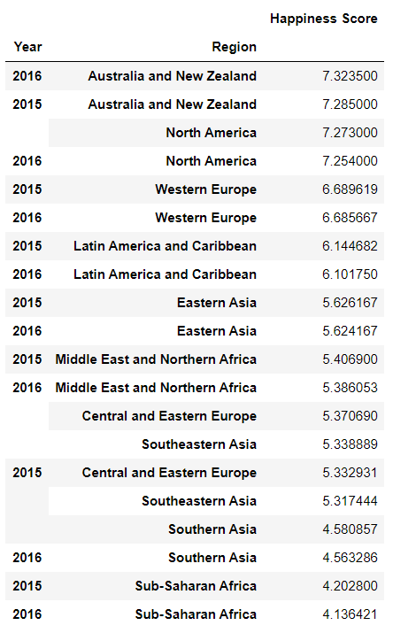

**Q2. *From the table, Find the Top 10 happy countries and top 10 Unhappy countries in Year 2017 and provide a Graphical Representation***

***ANS :***

***TOP 10 HAPPY COUNTRIES :***

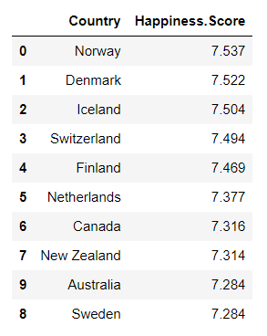

***GRAPHICAL REPRESENTATION :***

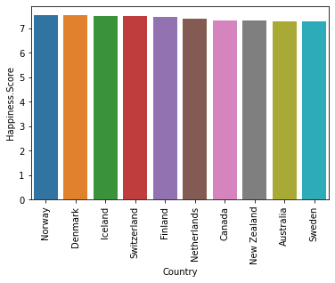

***TOP 10 UNHAPPY COUNTRIES :***

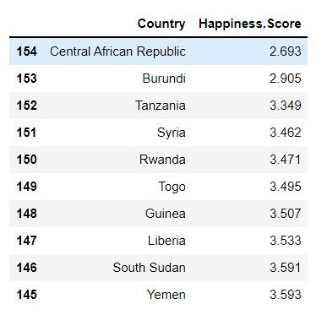

***GRAPHICAL REPRESENTATION :***

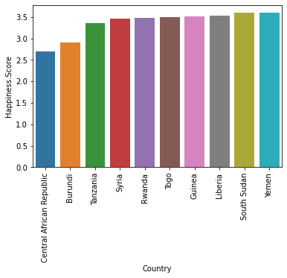

***Q3: What makes people happy in the year 2019.***

***ANS:***

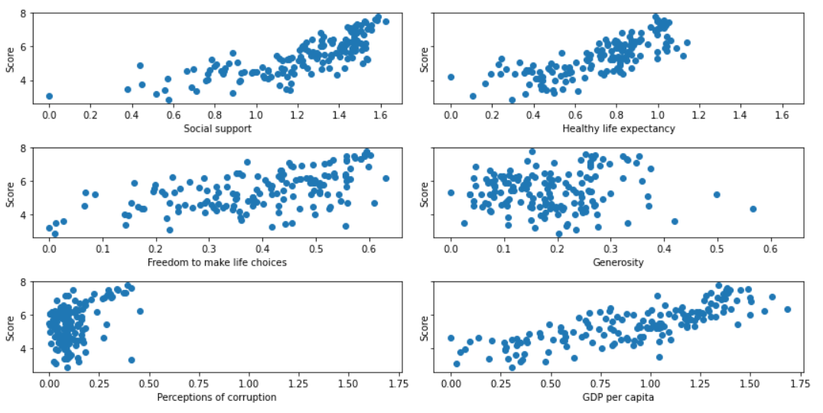

*From the above subplots, we can see that, except* ***Perception of corruption,*** *other things like* ***social support, health, life expectancy, Freedom to to make life choices, Generosity, GDP per Capita*** *makes people happy.*

***Q4. From the table, Find the Top 10 countries having highest GDP per capita and top 10 countries having Lowest GDP per capita in Year 2019 and provide a Graphical Representation***

***Ans:***

***Top 10 countries having highest GDP per capita***

***Country or region Freedom***

***Qatar 1.684***

***Luxembourg 1.609***

***Singapore 1.572***

***United Arab Emirates 1.503***

***Kuwait 1.500***

***Ireland 1.499***

***Norway 1.488***

***Switzerland 1.452***

***Hong Kong 1.438***

***United States 1.433***

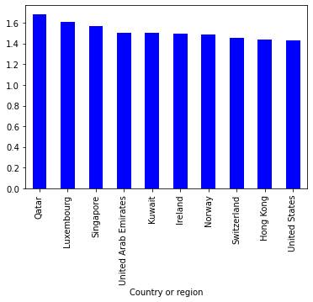

***Top 10 countries having Lowest GDP per capita***

***Country or region Freedom***

***Somalia 0.000***

***Central African Republic 0.026***

***Burundi 0.046***

***Liberia 0.073***

***Congo (Kinshasa) 0.094***

***Niger 0.138***

***Malawi 0.191***

***Mozambique 0.204***

***Sierra Leone 0.268***

***Madagascar 0.274***

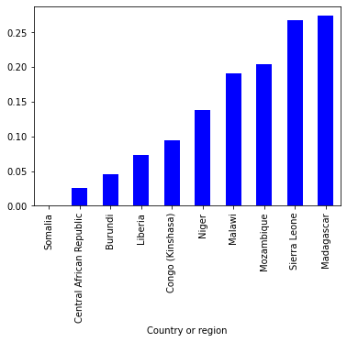

***Q5. Find the Top 10 countries with high freedom to***

***make life choices every year***

***ANS:***

***For 2015 :***

***Country Freedom***

***Norway 0.66973***

***Switzerland 0.66557***

***Cambodia 0.66246***

***Sweden 0.65980***

***Uzbekistan 0.65821***

***Australia 0.65124***

***Denmark 0.64938***

***Finland 0.64169***

***United Arab Emirates 0.64157***

***Qatar 0.64040***

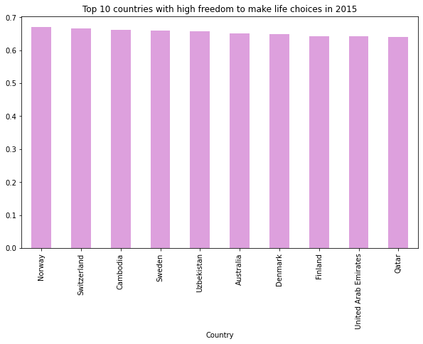

***FOR 2016 :***

***Country Freedom***

***Uzbekistan 0.60848***

***Norway 0.59609***

***Cambodia 0.58852***

***Switzerland 0.58557***

***Sweden 0.58218***

***New Zealand 0.58147***

***Denmark 0.57941***

***Canada 0.57370***

***Finland 0.57104***

***Australia 0.56837***

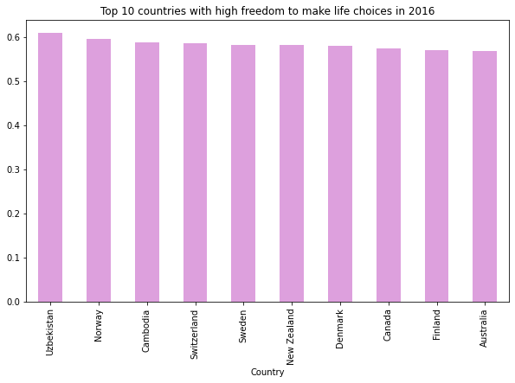

***For 2017 :***

***Country Freedom***

***Uzbekistan 0.658249***

***Norway 0.635423***

***Cambodia 0.633376***

***Iceland 0.627163***

***Denmark 0.626007***

***Switzerland 0.620071***

***Finland 0.617951***

***New Zealand 0.614062***

***Sweden 0.612924***

***Canada 0.611101***

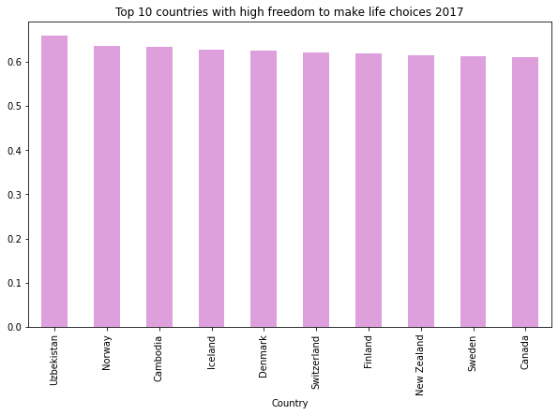

***For 2018***

***Country or region Freedom***

***Uzbekistan 0.724***

***Cambodia 0.696***

***Norway 0.686***

***Denmark 0.683***

***Finland 0.681***

***Iceland 0.677***

***Somalia 0.674***

***New Zealand 0.669***

***Switzerland 0.660***

***Sweden 0.659***

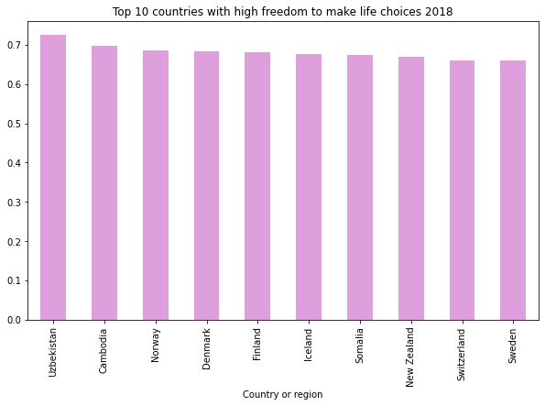

***For 2019 :***

***Country or region Freedom***

***Uzbekistan 0.631***

***Cambodia 0.609***

***Norway 0.603***

***United Arab Emirates 0.598***

***Finland 0.596***

***Denmark 0.592***

***Iceland 0.591***

***New Zealand 0.585***

***Canada 0.584***

***Sweden 0.574***

